

**A**

**Project Proposal**

**on**

**AI for Skin Disease Detection**

**Submitted By**

AMISHA BASNET (28903/078)

SAISA KOIRALA (28932/078)

SANDESH KHATIWADA (28936/078)

**Submitted To**

Er. Dhiraj Kumar Jha

Lecturer

Orchid International College

DEPARTMENT OF COMPUTER SCIENCE AND INFORMATION TECHNOLOGY

ORCHID INTERNATIONAL COLLEGE

**SUPERVISOR’S RECOMMENDATION**

I hereby recommend that the report prepared under my supervision by Amisha Basnet (TU Exam Roll No. 23803/078), Saisa Koirala (TU Exam Roll No. 23832/078), Sandesh Khatiwada (TU Exam Roll No. 23832/078) entitled **“AI for Skin Disease Detection”** in partial fulfillment of the requirements for the degree of B.Sc. in Computer Science and Information Technology be processed for evaluation.

**………………………….**

**Er. Dhiraj Kumar Jha**

Project Coordinator, Department of BSc. CSIT

Orchid International College

Bijayachowk, Gaushala

**ACKNOWLEDGEMENT**

We would like to express our heartfelt gratitude to all individuals who contributed to the completion of this report. First and foremost, our sincere thanks go to our project supervisor, Er. Dhiraj Kumar Jha, whose invaluable guidance, constant encouragement, and timely feedback greatly enhanced our work and learning.

We are also grateful to the Department of Computer Science and Information Technology at Orchid International College for providing us with the platform and resources to conduct this project. Our thanks extend to all teaching and non-teaching staff for their cooperation throughout this process.

We also appreciate the support from our friends and classmates for their constructive discussions and continuous motivation. Without their contributions, this report and project would not have been possible

Amisha Basnet (28903/078)

Saisa Koirala (28932/078)

Sandesh Khatiwada (28936/078)

**ABSTRACT**

People are becoming more conscious of the value of health in today's environment, and boosting general well-being depends heavily on early identification of skin conditions. If not identified in a timely manner, skin illnesses, particularly those like skin cancer, can be fatal. Using cutting-edge technology like machine learning can help with the early detection and categorization of skin lesions, giving people and healthcare professionals a useful tool to identify possible skin problems. Based on dermoscopic images, this suggested method classifies skin illnesses using a deep learning model. Users can input photographs of skin lesions to the system, and a pre-trained model created with TensorFlow and Keras is used to interpret and evaluate the images. The model provides a useful diagnostic and ranks potential diseases according to likelihood. Both the general public and medical professionals will find the program easy to use because to its Flask-powered user interface. By facilitating quicker response for skin-related health conditions, the system seeks to improve health outcomes by aiding in early detection, and prescribing medication.

***Keywords: Deep Learning, Skin Disease Classification, Flask, Image Processing, Early Diagnosis, Healthcare Application***

Table of Contents

CHAPTER 1: INTRODUCTION 1

1.1. Problem Statement 1

1.2. Objectives 2

1.3. Scope and Limitations 2

1.4. Development Methodology 2

CHAPTER 2: BACKGROUND AND LITERATURE REVIEW 4

2.1. Background Study 4

2.2 Literature Review 5

# INTRODUCTION

Skin conditions are a prevalent global health problem, observed in individuals of all ages. The symptoms, which vary from widespread such as acne and eczema to life-threatening conditions such as melanoma and psoriasis, are often not diagnosed or misdiagnosed, particularly where there are no dermatology skills. Traditional diagnostic methods are plagued by human bias and inability to scale.

With advances in Artificial Intelligence (AI) technologies, particularly deep learning and image classification, it is now feasible to create systems that are capable of detecting diseases from images with high accuracy. This project aims to utilize such AI technologies using CNN, MobileNet, and DenseNet121 models to diagnose dermatological images.

The mission is to create a supportive AI product that facilitates early diagnosis, reduces healthcare infrastructure overload, and improves access to care in under-resourced regions.

## Problem Statement

Although skin diseases are common, early and accurate diagnosis remains a significant issue, especially in regions where experts lack good access. Delayed or incorrect diagnosis may lead to serious complications. Traditional visual diagnosis methods are subjective and unreliable. The project addresses these issues by proposing a deep learning-based tool to diagnose skin diseases from dermoscopic images for rapid, accurate, and low-cost diagnosis.

## Objectives

* To build a deep learning-based classification model for skin diseases using image data.
* To build and train deep learning models (CNN, MobileNet, DenseNet121) for accurate skin disease classification.
* To compare the performance of these models using evaluation metrics such as accuracy, loss, and confusion matrix.
* To deploy the model through a simple web interface for user interaction.

## Scope and Limitations

This project focuses solely on classifying skin diseases using static clinical image data through deep learning models. It aims to provide early detection and awareness but excludes real-time diagnostics, external device integration, and live patient monitoring. The system functions as a standalone assistive tool and is not a certified medical diagnostic product. Its effectiveness depends on clear image input and the quality and diversity of the dataset.

## Development Methodology

The project follows an incremental delivery approach, dividing development into a series of small, manageable iterations. Each iteration builds upon the previous one by adding new features, enabling continuous progress and flexibility. This method suits projects with evolving requirements or high complexity by allowing regular feedback and adjustments throughout the process. For this project, the initial iteration established core functions such as web scraping for news collection and basic data processing. Later iterations enhanced classification accuracy and summarization techniques. Each stage was thoroughly tested to ensure reliability before moving forward. Overall, this approach enabled a flexible, adaptive development process that successfully delivered a functional and robust system.

**Report Organization**  
The report is structured into six chapters:

1. Introduction - covering project overview, problem statement, objectives, scope, constraints, and development methodology.
2. Background Study - reviewing relevant theories, concepts, and similar works by others.
3. Analysis - including system requirements and feasibility analysis.
4. System Design - detailing the overall design and architecture.
5. Implementation and Testing - describing tools used and testing procedures.
6. 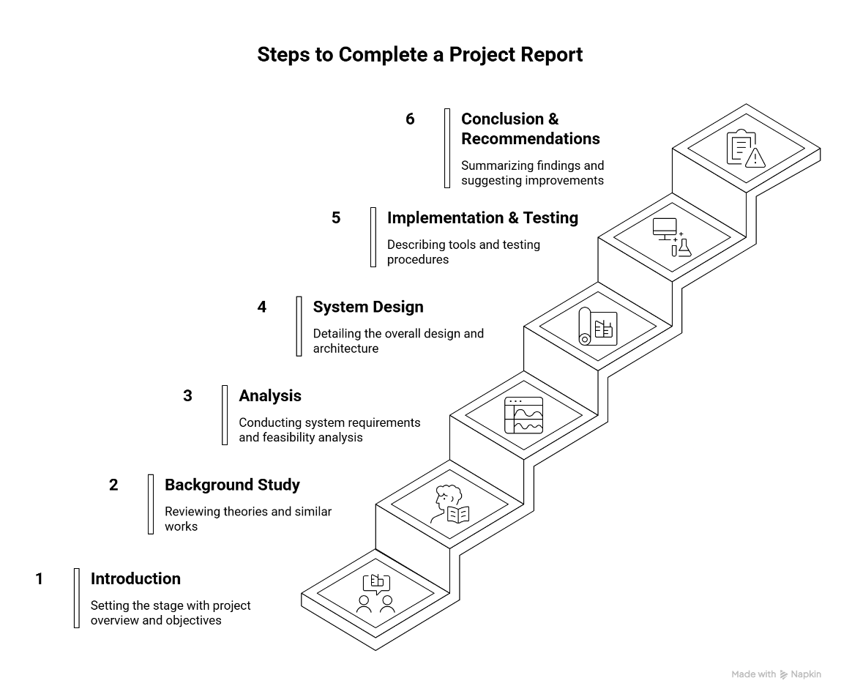Conclusion and Future Recommendations - summarizing findings and suggesting improvements.

Figure 1.1: Report Organization

# BACKGROUND AND LITERATURE REVIEW

## 2.1. Background Study

Skin diseases, particularly melanoma, continue to pose serious threats to public health, especially in countries such as New Zealand, Australia, and the United States, where incidence rates have significantly risen in recent decades. Melanoma, which arises due to the uncontrolled growth of melanocytes, is one of the deadliest forms of skin cancer. Early detection of melanoma significantly increases survival rates, yet accurate diagnosis remains challenging due to visual similarities between benign and malignant lesions and overlapping features with normal skin.

Traditionally, dermatologists rely on dermoscopic images and manual analysis to diagnose skin lesions. However, this process demands extensive clinical expertise and is time-consuming. In response, computer-aided diagnosis systems powered by Artificial Intelligence (AI) and Machine Learning (ML) have emerged as a promising alternative to assist in early and accurate detection.

The advancement of Deep Learning (DL), especially Convolutional Neural Networks (CNNs), has revolutionized image classification tasks. CNNs have shown remarkable success in recognizing complex patterns in medical imaging, including skin lesion classification. This approach leverages hierarchical feature extraction, mimicking the human visual cortex, to effectively learn and distinguish between various lesion types.

In the research conducted by Viswanatha Reddy Allugunti, a deep learning-based CNN model is developed to classify types of melanoma - including lesion maligna, superficial spreading, and nodular melanoma. The model achieves high classification accuracy (88.83%) and outperforms traditional ML algorithms such as Decision Trees, Random Forests, and Gradient Boosted Trees. The research underscores the potential of CNNs to serve as a powerful diagnostic support tool, aiding clinicians in early melanoma detection and treatment planning.

## 2.2 Literature Review

Numerous researchers have explored automated methods for skin lesion analysis, combining classical machine learning algorithms with modern deep learning techniques to improve diagnostic performance.

In one study [7], the authors introduced Lesion Feature Network (LFN) and Lesion Indexing Network (LIN), which used fully convolutional residual networks to segment and classify lesions. A distance heat map-based lesion index calculation unit (LICU) was introduced to enhance classification accuracy using ISIC 2017 data.

Another work [8] proposed a 19-layer deep CNN for automatic lesion segmentation, introducing a novel Jaccard-based loss function to mitigate class imbalance during training. This approach was validated using ISBI 2016 and PH2 public datasets and demonstrated high segmentation efficiency.

A landmark study [9] utilized a CNN trained from scratch on over 129,000 clinical images. The model demonstrated dermatologist-level accuracy when tested against board-certified experts in two binary classification scenarios: distinguishing between keratinocyte carcinomas and seborrheic keratoses, and between malignant melanomas and benign nevi.

In contrast to earlier shallow architectures or handcrafted feature methods, [10] proposed deeper CNNs using residual learning to combat overfitting and degradation issues. The research introduced a two-stage architecture using Fully Convolutional Residual Networks and multi-scale feature integration, improving lesion classification from segmented dermoscopic images.

Rashmi Patil et al. [11] developed the SMTP loss function to enhance sensitivity, specificity, and accuracy in melanoma classification. Their model successfully segmented melanoma into stages and demonstrated the advantage of a gradient-based similarity approach.

Korotkov et al. [12] addressed lesion matching in full-body clinical images, assisting longitudinal tracking of lesion progression for early melanoma detection. Their matching algorithm aligned lesion regions in sequential images, supporting comprehensive skin evaluations.

Kassem et al. [9] applied transfer learning with GoogleNet on the ISIC 2019 dataset, achieving precision of 94.92% despite class imbalance. Their model outperformed others like VGG19 and ResNet50, especially when the class distribution was normalized and architectural weights were fine-tuned.

Saleh Albahli et al. incorporated morphological preprocessing and YOLOv4 object detection for robust lesion segmentation. Their technique successfully isolated melanoma-infected regions across ISIC 2016 and 2018 datasets, enabling more accurate detection.

Lisheng Wei proposed a lightweight CNN model combining lesion classification and similarity analysis via a feature discriminating branch network. This design reduced parameter count while maintaining or surpassing accuracy achieved by multi-CNN fusion approaches.

Lastly, Ichim et al. [10] introduced a dual-stage classifier system using conditional GANs and multiple neural networks. Their model achieved 97.5% accuracy by integrating TDS scores into the final classification stage, demonstrating effective database adaptability.